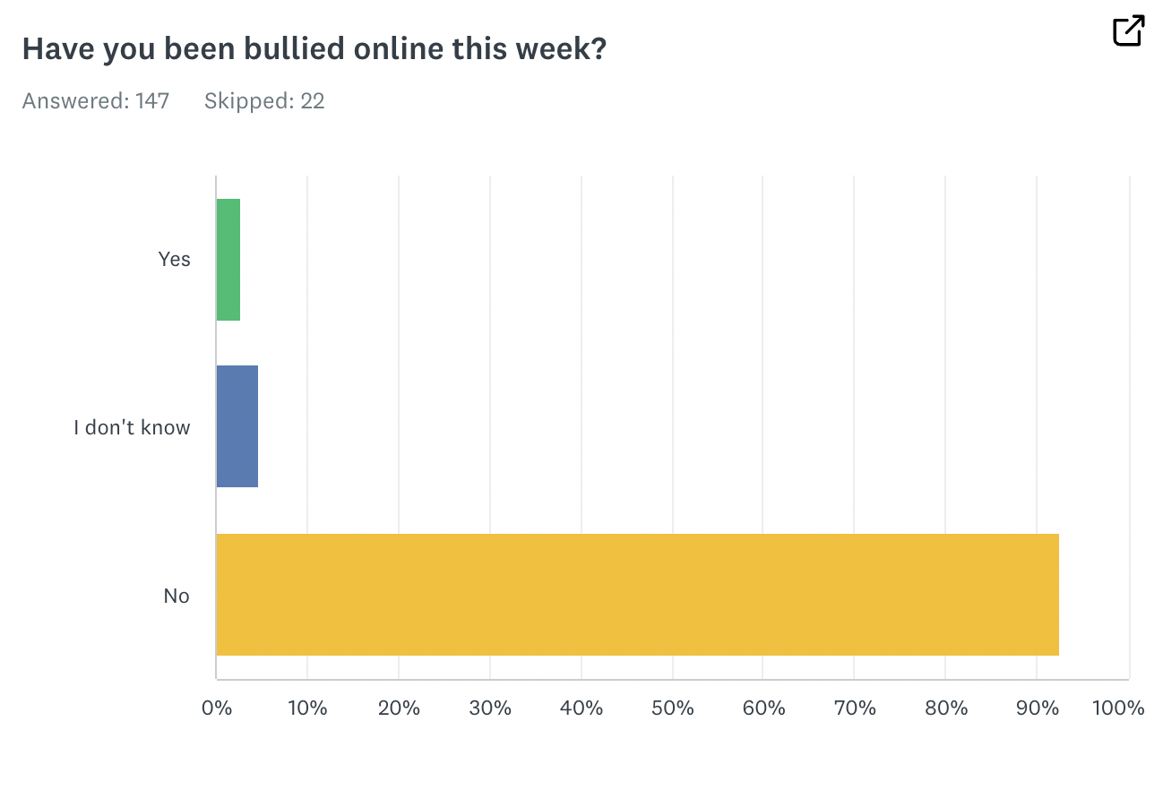

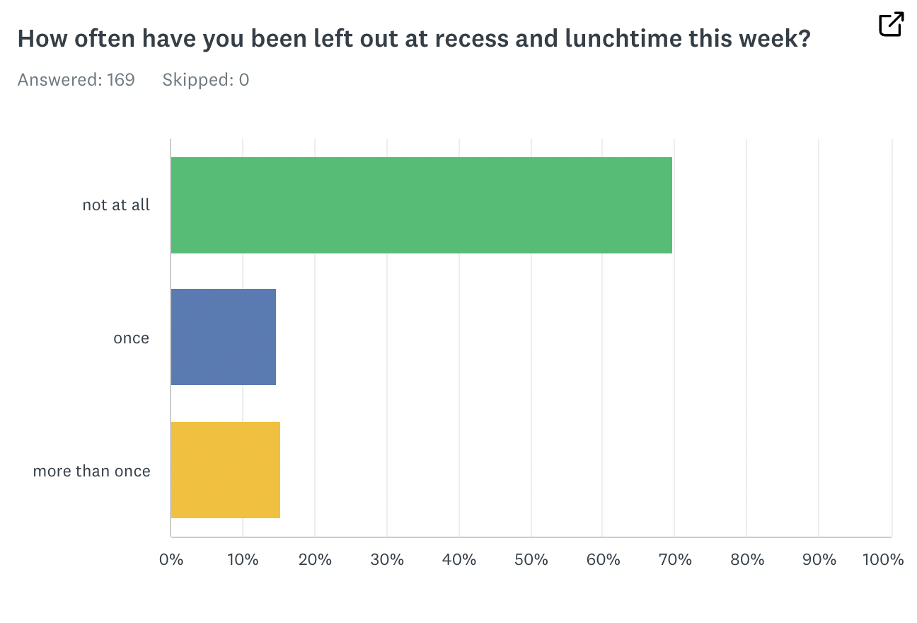

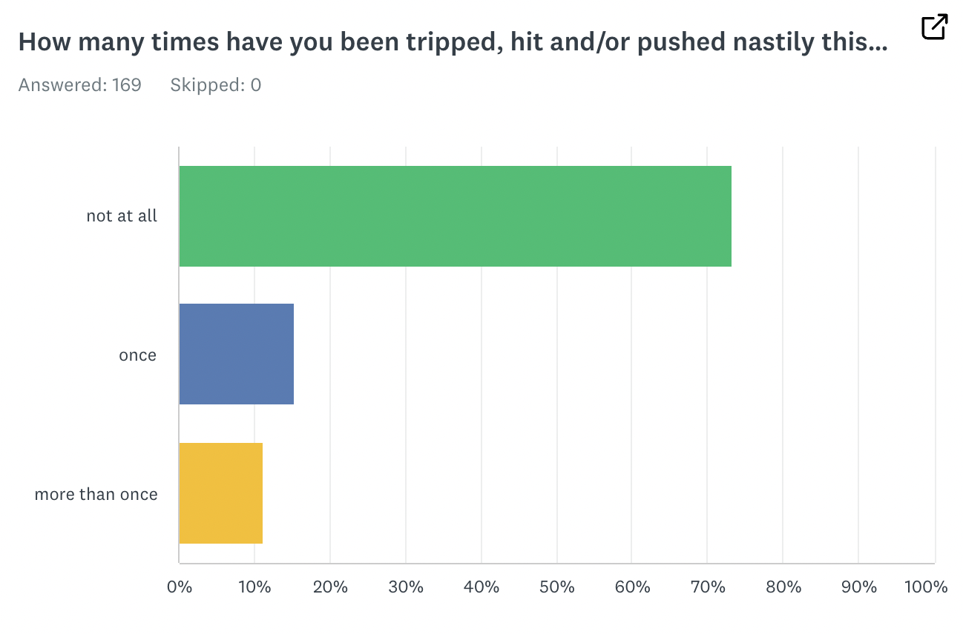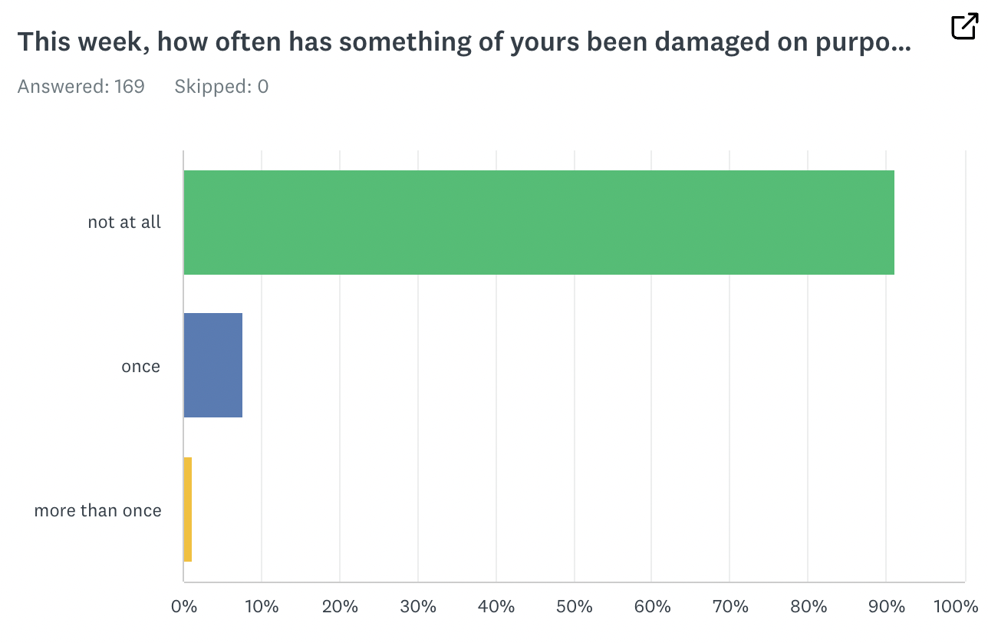

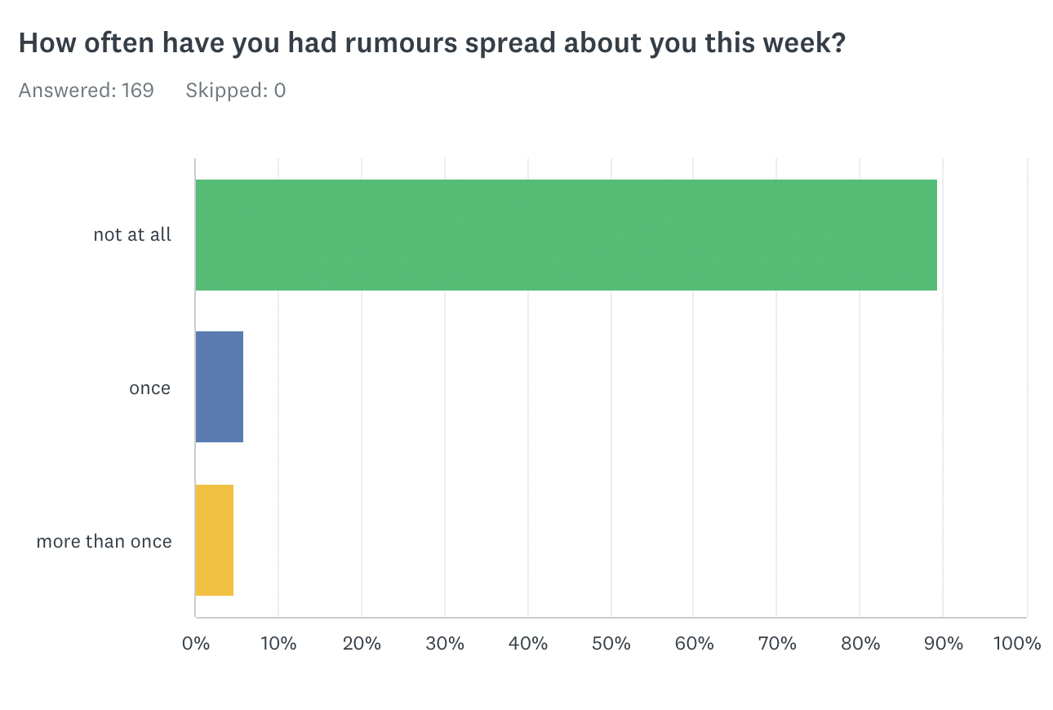

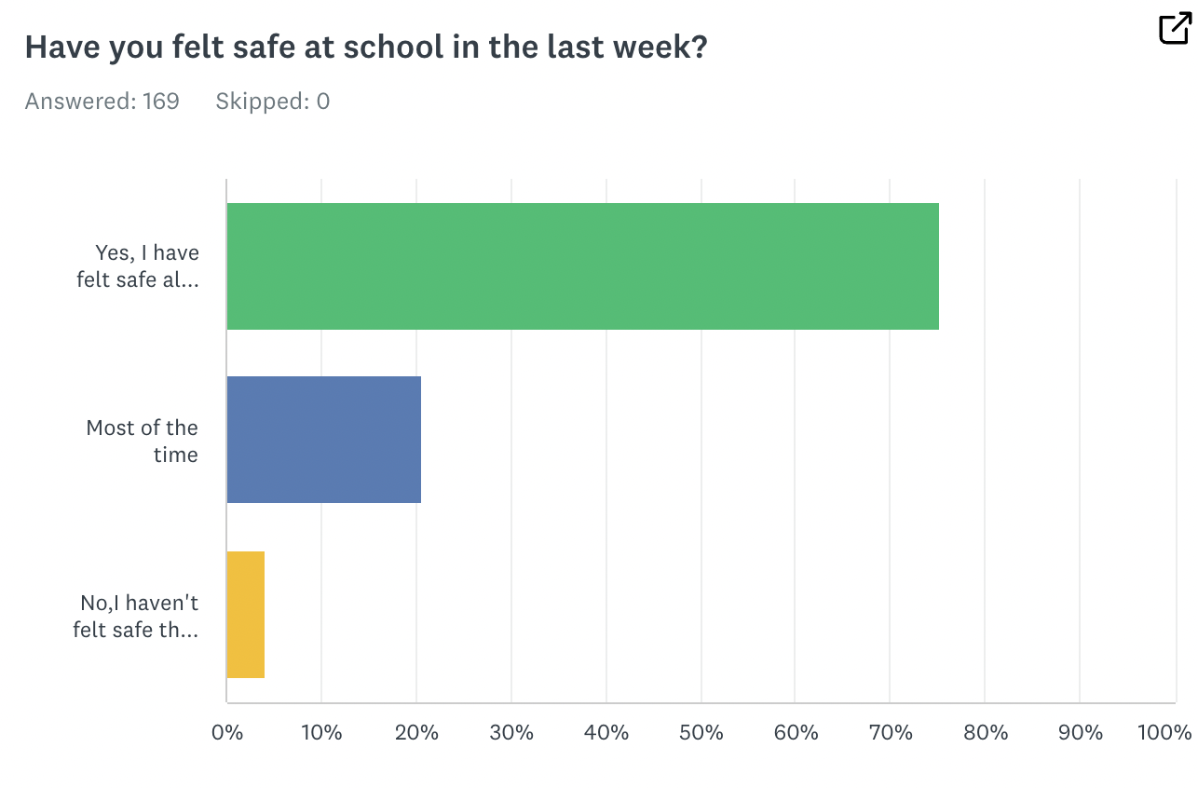

What has made you feel unsafe? 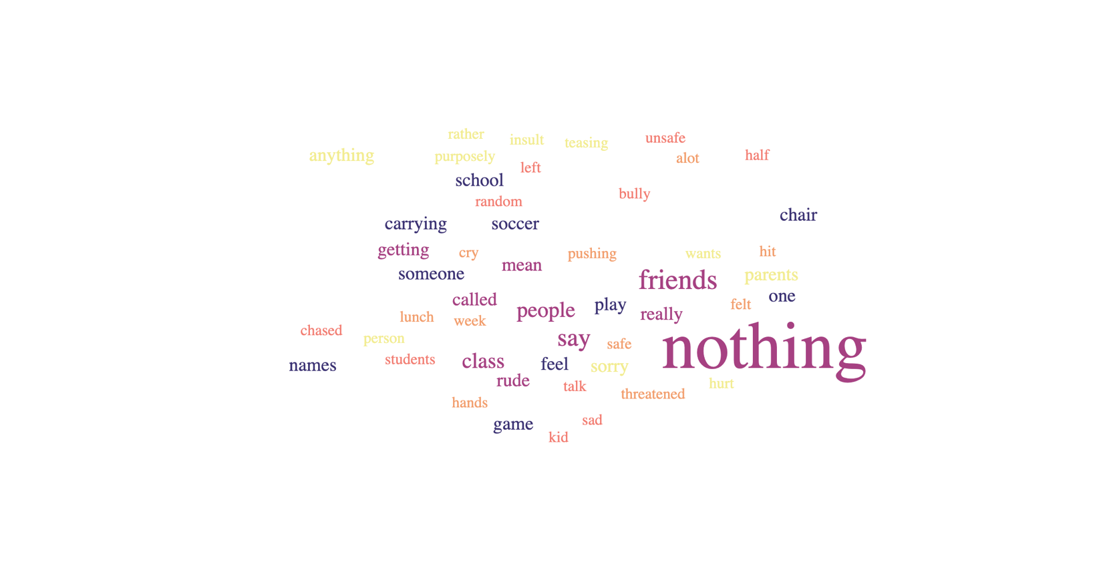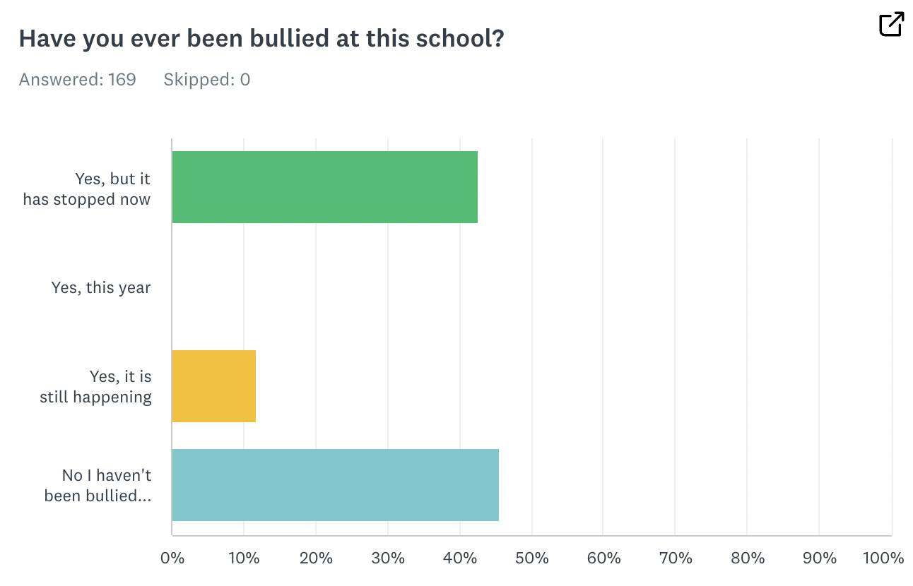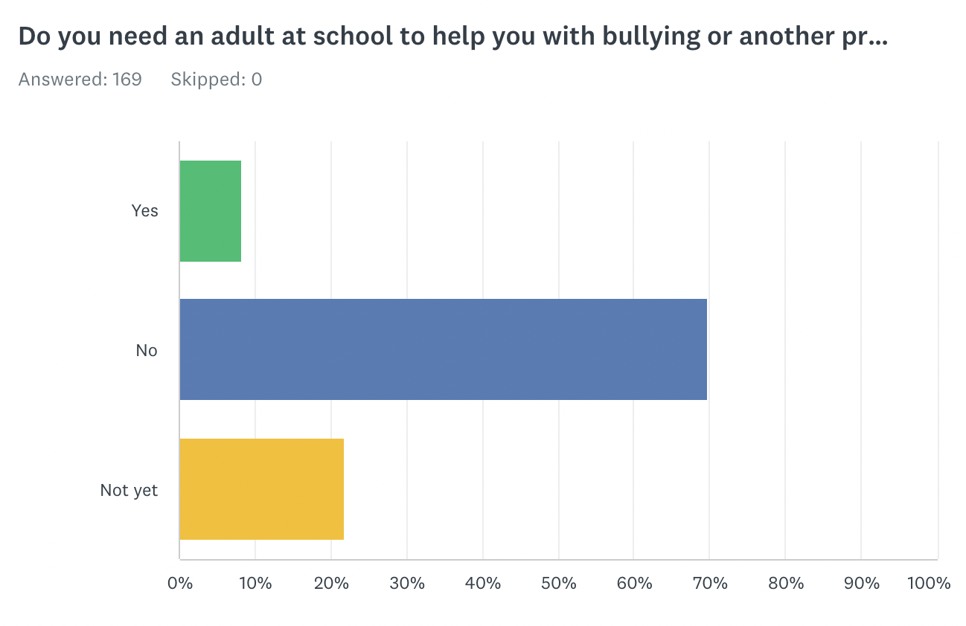

What would you like help with? (7 responses)

* Stopping the person who is bullying me
* Standing up for my self
* Staying safe
* stop calling me names
* stop the person bullying me
* Friendships
* Writin

Please tell us of one time when you helped someone who was being teased/harassed or bullied (114 responses)

