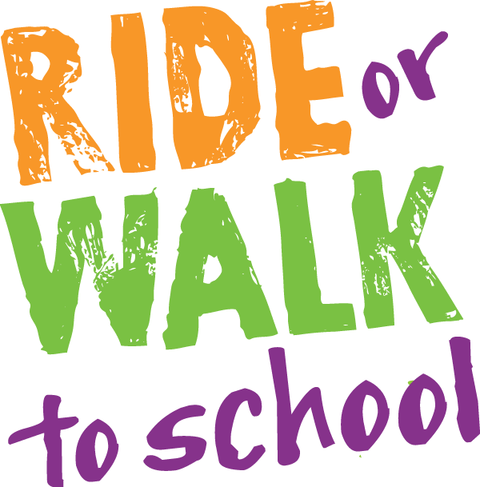

National Ride2School Day is held around Australia. It provides an opportunity for students, parents and teachers to try riding, walking, skating or scooting to school as well as celebrating the regular walkers and riders.

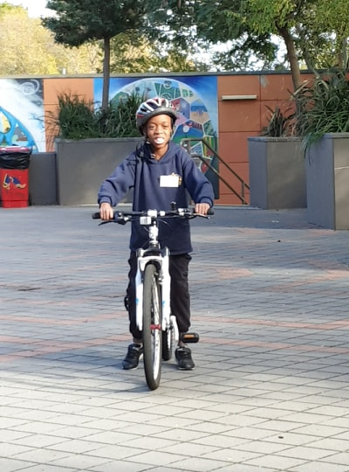
Wednesday 19th June.
Bring your bikes to school.
Leave them in the castle area.
This space will be out of bounds at recess and lunchtime.

Students can win points for their Sports Day team by participating in this event.

