**OSHC NEWS**

**TERM 2**

**To all Parents & Caregivers,**

Welcome back to OSHC! Term 2’s theme is “Play, Learn, Explore”. We will have more news and photos as we expand on this theme.

**Breakfast at OSHC**

From Monday 22 May, OSHC will be providing breakfast at Before School Care on Mondays, Wednesdays and Fridays, as we are receiving bread from Bakers’ Delight. This will run from 7:15 to 7:45am. For those using Before School Care, this might help with the morning rush!

**Easter Raffle Winners**

C:\Program Files (x86)\Microsoft Office\Media\CntCD1\ClipArt3\j0237792.wmfOur Easter Raffle was a huge success and, with your help, we raised $208.00 for CanTeen, supporting childhood cancer.

Our winners were:

1st Prize – The Hayford Family

2nd Prize – Lachlan Warren

3rd Prize – Elijah Patino

4th Prize – Kerri Bruggeman

Thank you to everyone who donated items and supported our Easter Raffle.

**April Vacation Care**

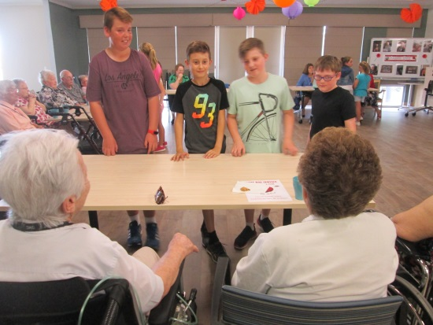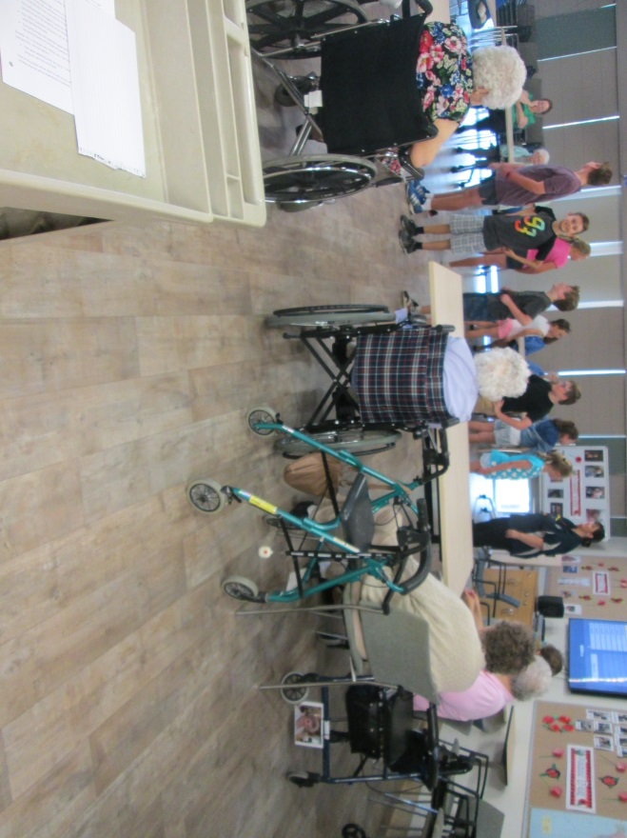During the recent April Vacation care, children visited Grandview Aged Care Centre at Trott Park, where they sang and danced for the elderly residents, which was thoroughly enjoyed.

We are hoping to visit again during the next holidays.

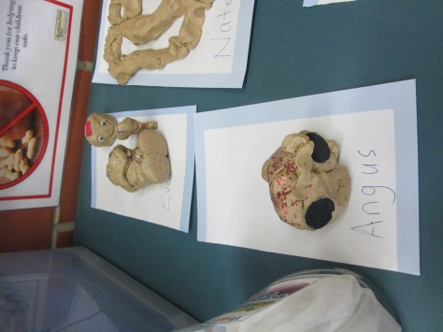

Vacation Care went well with the children having lots of fun.

Some of our excursions were to Bounce, Lollipops Play Café and Hallett Cove Conservation Park.



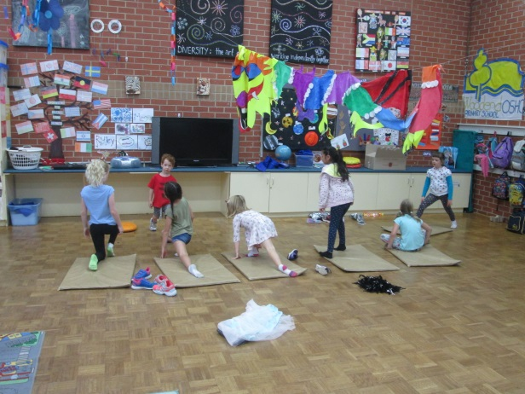

During July Vacation Care, we will be having a Market Day. If any families have any ‘as new’ unwanted items they would love to donate, we would be extremely grateful.

**Craft Donations**

Thank you to families who have donated boxes, DVDs and craft supplies, we are always grateful. Just a reminder that we are unable to accept meat trays, washing powder boxes and animal or used food products due to our Child Safety guidelines, but please keep other supplies coming!

**Look at our Hall**

The OSHC Hall is looking wonderful, filled with displays. Please come in and take a look at the children’s work.

Please feel free to leave any feedback for us via email or come in and see us, we always have open ears.

**Term 1 and April Vacation Care Fees**

Just a reminder that all Term 1 and Vacation Care fees are due for payment by the end of week 4, Friday 26 May.

**Fee Increase**

For those of you who haven’t seen the notice in the OSHC Hall or on your invoices, please note that fees for Before School Care have increased to $14.00 per session. This decision was made by the school’s principal, due to rising costs and was approved by Governing Council. Should you have any queries regarding this increase, please contact Principal, Steve Freeman.

**Cancellations**

As per our OSHC Policy, we must receive 2 full business days’ notice in order to cancel a booking without charge. We realise this can be difficult at times, particularly when cancelling for Mondays at short notice, but this decision was made by Governing Council. You do not need to come in to cancel a booking…you can email us on [dl.1056.oshc@schools.sa.edu.au](mailto:dl.1056.oshc@schools.sa.edu.au) or leave a voice message or text on our mobile 0411 274 747. Emailing and texting/voice mail also leaves a time stamp, so there can be no uncertainty over the notice given.

**Jackie and the OSHC Team.**